# Sample answer to the Mock questions.

Note for the solution: there isn’t only one correct solution, the correct solution can be based on your assumptions(you may not get MAX marks if your assumption makes the solution easier than the real scenario)

# Question 1.

Which design database concepts has the person who created the schema above not followed?

“Students should know what is expected in an ERD. For example, the names of the PKs and FKs should match, there should not be any duplication of data, etc. These general principles underly all methods of database design, both normalisation and object oriented.”

1. No foreign key in SubTopic
2. CreatedBy fields are duplicate in many tables, should create another table named Teacher and create links to that table
3. The PupilSite should have relation to Fact not SubTopic because pupils are the owners of Fact
4. The PupilName can not be primary of PuplileSite, The primary key should be SiteAddress because pupils could have the same name
5. Remove CreatedBy in Fact because once Fact and PupliSite connected to each other, we can know who created the Fact
6. We should not store pupilName as one field but separate them in to FirstName and LastName to meet 1st Norm

# Question 2

Create an improved conceptual ERD for the scenario above

“This now gets specific. What should a conceptual ERD show? For example, PKs should be underlined, the cardinalities of the relationships should be shown, sub-classes (if required) should be shown, etc. The emphasis here is NOT on a detailed understanding of the scenario, but rather the creation of an industry standard diagram. A student who is not familiar with the topic of the scenario will not be penalised for making any reasonable assumptions.”

With the assumption that:

Teacher can create 0..M Topic or SubTopic

We don’t store any other information of Pupil except: FirstName, LastName and SiteAdddress, if Pupil has more information we need to create another table Pupil

Each Pupil has only one Website which has many Facts

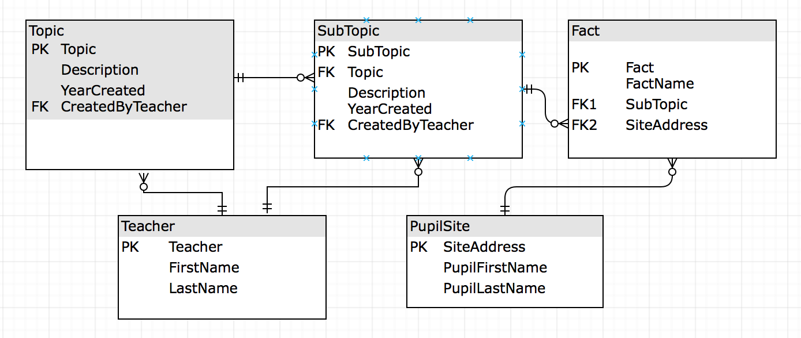

# Question 3

Create an improved physical ERD for the scenario above.

“This requires the student to create a physical ERD based upon their design in question 2. What is being assessed here is the knowledge of how to turn a conceptual ERD into a physical one. This means that the student is not penalised if their answer to question 2 has flaws. For example, the marking scheme awards marks for the correct resolution of sub-classes, the correct placement and naming of FKs, the identification of suitable data types for each field.”

Teacher(Teacher varchar(50) **PK**, FirstName varchar(50), LastName varchar(50))

Topic(Topic varchar(50) **PK**, Description varchar(50), YearCreated int, CreatedByTeacher varchar(50) **FK**)

SubTopic(SubTopic varchar(50) **PK**,Topic varchar(50) **FK**, Description varchar(50), YearCreated int, CreatedByTeacher varchar(50) **PK**)

PupilSite(SiteAddress varchar(50) **PK**, PupilFirstName varchar(50), PupilLastName varchar(50))

Fact(Fact varchar(50) **PK**, FactName varchar(50),SubTopic varchar(50) **FK** , SiteAddress varchar(50) **FK**)

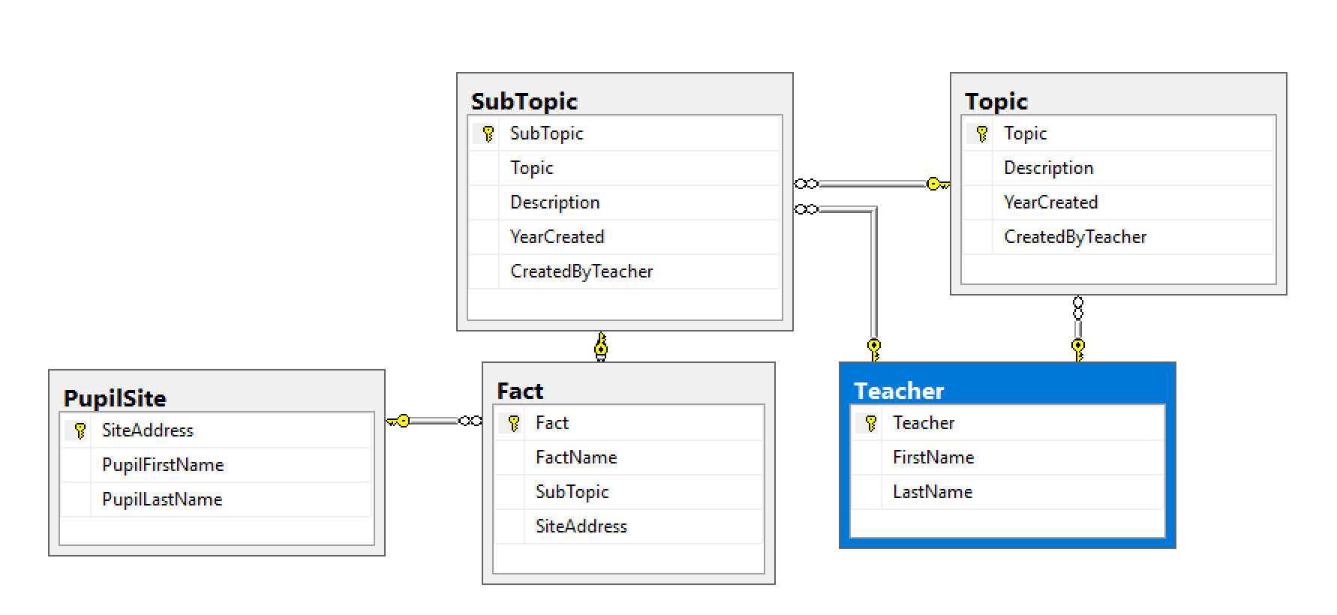

# Question 4

Give the SQL for your physical design which will list those topics and sub-topics which have the person who created them in common.

“*This is an examination and you will not have computers available, therefore “silly” mistakes such as misspelling a word or using a comma at the end instead of a semi-colon will NOT be penalised. Students should show both an appreciation of the syntax of SQL (e.g. SELECT … FROM … WHERE … etc.) as well as the logic of the command(s) being created. Imagine this as the first draft of query before testing it.”*

select t.Topic,

s.SubTopic,

Te.FirstName + ' ' + te.LastName as 'Full Name'

from topic t,

SubTopic s,

Teacher Te

where t.CreatedByTeacher = s.CreatedByTeacher

and t.CreatedByTeacher = Te.Teacher

# Question 5

Which views and indexes could improve the performance of your queries? Explain your answers.

“*This question examines the knowledge students have of some of the more technical aspects of database implementation. For example, the types of views and how they are implemented and/or the types of indexes and how they are implemented might be asked. Students should show both a practical and theoretical understanding of these areas of the syllabus*.”

**Index**

To improve the performance of the query above, some Indexes should be created. Normally we need to look at the Where clause of the Query. In this cases some indexes should be created:

* CreateByTeacher on table Topic and table SubTopic.
* Teacher on table Teacher

create index idx_teacher1 on Topic(CreatedByTeacher)

create index idx_teacher2 on SubTopic(CreatedByTeacher)

create index idx_teacher3 on Teacher(Teacher)

3 Indexes named idx_teacher1, idx_teacher2, idx_teacher3 were created on 3 tables Topic, SubTopic, Teacher. The fields to create index are the fields in the where clause

**View**

If we create Materialized view we can more improve the performance but the data between Tables and View could not synchronized at some times

In SQL Server Materialized view is created by Creating a view and an Index

--Step 1: create View

create view TopicAndSubTopic

WITH SCHEMABINDING

as

select t.Topic,

s.SubTopic,

Te.FirstName + ' ' + te.LastName as 'Full Name'

from dbo.topic t,

dbo.SubTopic s,

dbo.Teacher Te

where t.CreatedByTeacher = s.CreatedByTeacher

and t.CreatedByTeacher = Te.Teacher

--step 2: create unique cluster index

CREATE UNIQUE CLUSTERED INDEX IDX_V1

ON TopicAndSubTopic (Topic,SubTopic,[Full Name]);

Question 6

Explain what ACID is and how it might be helpful in this situation

Look at Week 7(Concurrency Problems)

**Video:** https://youtu.be/NHKHzwolbKU

•**Atomicity** – _The transaction is either fully completed or it is not. Nearly all completed is not allowed. Use COMMIT and ROLLBACK for this.

• **Consistency** – _No constraints are violated, i.e. the data is in the format expected by all constraints, cascades and triggers.

• **Isolation** – _The actions of one user should not affect the actions of other users. It should be as if the two transactions were sequential.

• **Durability** – _A transaction should stay in that state once it has been committed, even if there are power outs or errors.

Question 7

Either create the relational algebra expression for the query you created for question 4 or its logic tree.

“*This covers the relational algebra and will require the student to turn their answer to question 4 into both a relational algebra expression and/or a logic tree. Students who de-normalised their DB design to make question 4 easier will also lose marks here indirectly because they will not be able to show a range of tools.”*

select T.Topic,

S.SubTopic,

Te.FirstName

from topic T,

SubTopic S,

Teacher Te

where T.CreatedByTeacher = S.CreatedByTeacher

and T.CreatedByTeacher = Te.Teacher

ΠT.Topic,S.SubTopic, Te.FirstName(S |X|θCreatedByTeacher_id= θCreatedByTeacher_id T |X|θCreatedByTeacher_id=TeacherTe)

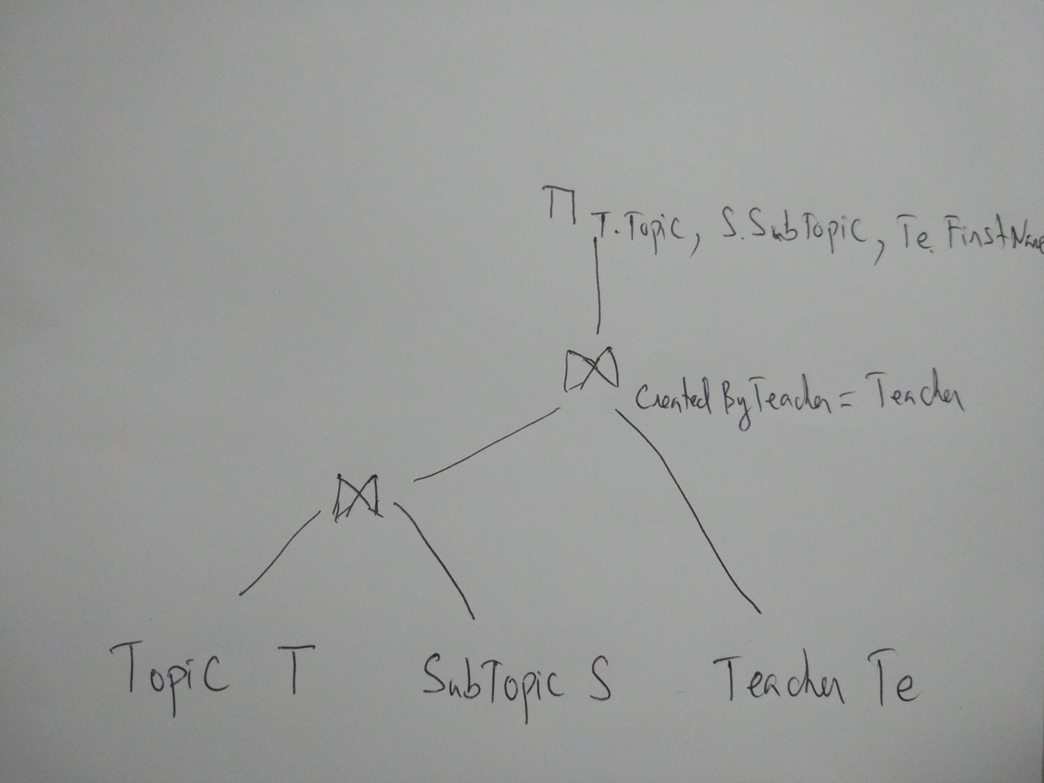

Another example of algebra expression from

https://courses.cs.washington.edu/courses/cse444/10su/sections/section7-query_execution-solution.pdf

